* **Activity 9:**

Using the EXISTS Operator

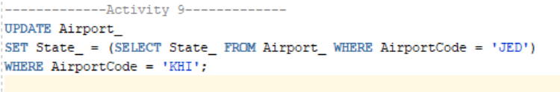

OUTPUT:

